Task 1: Multithreaded counter using pthread_create() and pthread_join()
Code:
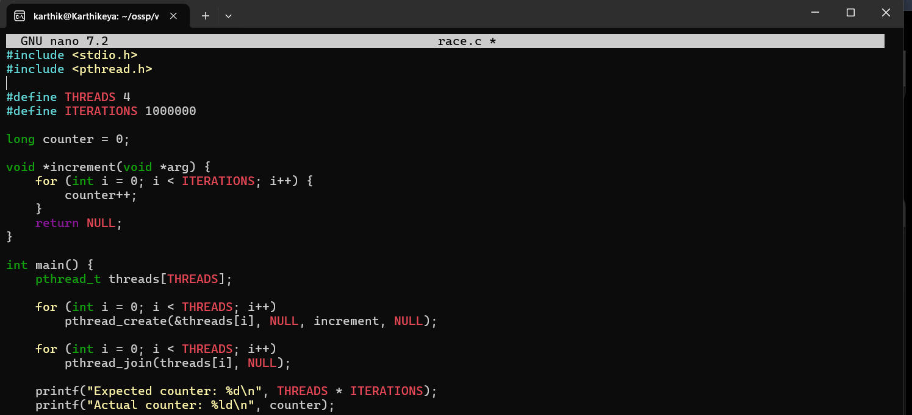

Output:
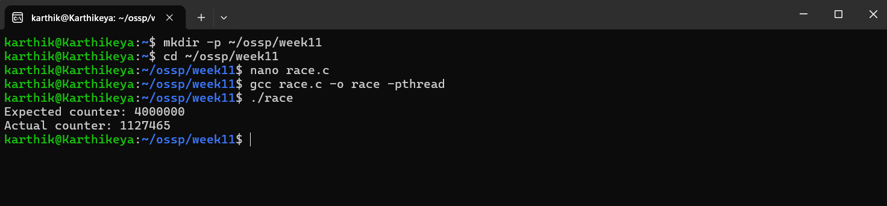

Task 2: Fix the race condtion using a mutex
Code:
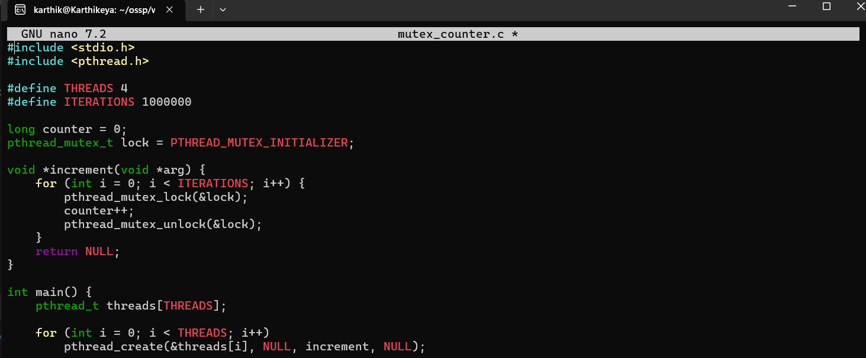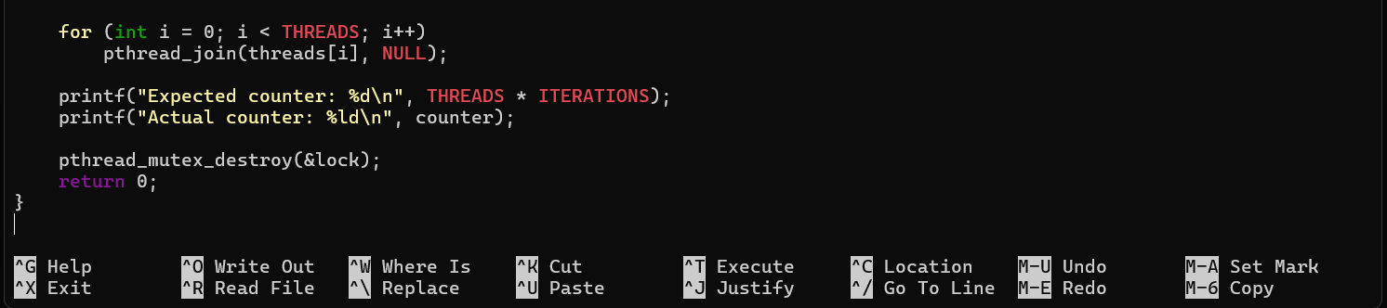

Output:
